Satellite & Mobile Communication Network 07.09.2020
TV Transmission
1. TV Signal:
Video: 0 to 5 MHz
Audio Music: 0 to 20 KHz
2. TV Music ⇒ Stereo
2 audio channels in the image below
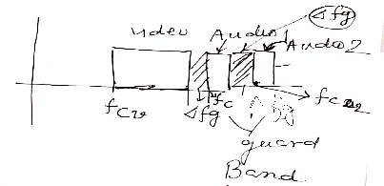
f_{cv} = carrier for video
f_{ca1} = carrier for audio channel 1
f_{ca2} = carrier for audio channel 2
3. Assume both video and audio music Amplitude Modulated:
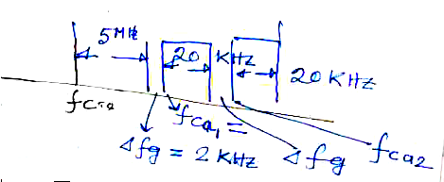Neglecting guard band
Total TV bandwidth required = 5 MHz + 2 * 20 KHz
= 5.040 MHz
4. Assume all frequency modulated video and audio:
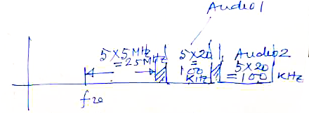Total bandwidth required = 25 MHz + (100 + 100) KHz
= 25.2 MHz
Because of very high channel bandwidth, video FM is discarded.
5. Video AM and Audio FM: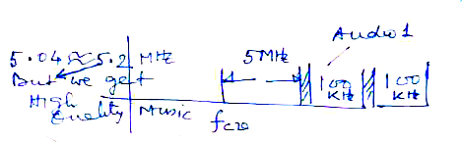

Total bandwidth = 5 MHz + 200 KHz
= 5.2 MHz
6. From (3) BW_{Total} = 5.04 MHz
From (5) BW_{Total} = 5.2 MHz
Analog vs Digital Transmission
Quality of transmission of digital signals is much better than the analog signal + other benefits. Why? 1. Digital signal after some distance of propagation can be regenerated to its original form which the analog signal cannot be.
a.
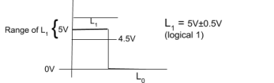b.
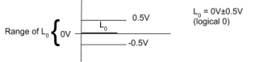Suppose our transmission sequence is 1010…
L₁ affected by -0.4V noise (negative noise)
L₀ affected by +0.4V noise (positive noise)
c.
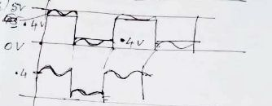
d. At receiver 4.5V ≤ voltage ⇒ Replace by L₁
Voltage ≤ 0.5V ⇒ Replace by L₀
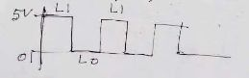
e. Then amplified to compensate for the power loss.
Whole process is the regeneration of digital signals.
Regeneration = Amplification + Reshaping
f. If there is a positive noise > 0.5V then 0’s will be affected and signal cannot be reshaped. g. If there is negative noise where mod value > 0.5V then digital 1’s will be affected. h. Above (f) and (g) will cause transmission error which can be taken care of by digital transmission by error coding and retransmission scheme.
None of the above can be taken care of in analog transmission.
2. Digital data can be stored and processed by digital computer. This cannot be done for analog signal of analog transmission.
3. Due to the above capability (2) of digital computers the following can be done for only digital transmission.
a. Data can be compressed to save transmission bandwidth.
For example:
● Digital music can be compressed using the MP3 algorithm.
● Digital video can be compressed using MPEG4 compression algorithm.
These compression algorithms are lossy.
● Not Suitable for computer data.
o Banking
o Student result
● But suitable for video and music.
b. Data can be encrypted and decrypted to stop data surveillance by intruders over space. c. In case of transmission error:
i. Error detecting codes (CRC) algorithm can be used to identify if any transmission error has taken place.
ii. If so, then there can be an error recovery algorithm (like stop and wait, sliding window) protocol algorithm can be executed to take care of transmission error. iii. Also error correcting codes can be used but (i) and (ii) is used for computer data communication.
Digitization of Voice
1. If a signal has got maximum frequency f_{sm}, then according to Nyquist criteria or theorem. No. of samples per second = 2 * f_{sm}
Each sample is digitized using n bit/sample.
So total transmission rate of voice/music = 2 * f_{sm} * n
- For telephonic voice, f_{sm} = 4 kHz
n = 8 bit
Data rate for telephonic voice = 4 * 2 * 8 = 64 kbps
- For music, f_{sm} = 20 kHz
n = 16 bit
Data rate for music for mono music = 20 * 2 * 16 kbps - For stereo music = 2 * Mono channel
Actually music bandwidth = 21.5 kHz (Not 20 kHz)
Calculate value of 2 * 21.5 * 2 * 16 kbps
⇒ Uncompressed Stereo bandwidth music
⇒ MP3 compression 144 kbps
Video Digitization: Digital Video Camera
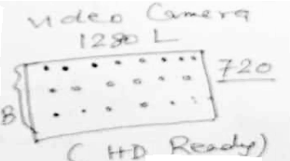
Total aspect ratio = (B/L) = (3/4)² = 9/16
(Earlier aspect ratio = 3/4)
One Screen = One Frame = 1280 * 720
One TV frame = 1280 * 720 * 24 bit
To bring continuity of motion picture 50 frames/second Total data rate after Digitization = 1280 * 720 * 24 * 50 Compressed by MPEG4 (MP4) = 2 to 6 Mbps (variable bit rate) Example:
Classroom video = 2 Mbps
Horse race or mountain range = 6 Mbps

